**100Hz 0.1Amp Sine for 0.1s, 8-bit data/audio**

Data sent to OpenAL functions:

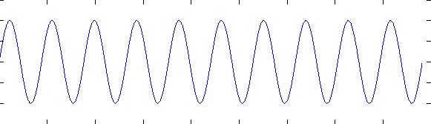

Resulting audio:

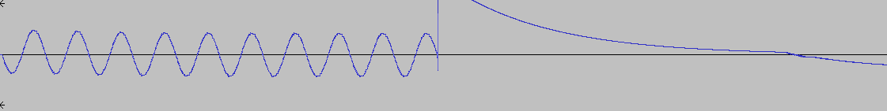

(and for 1.0s)

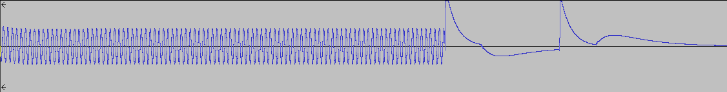

**100Hz 0.1Amp Sine for 0.1s, 8-bit data/audio, With 1000-sample fade-out**

Peaks at end are still there.

**100Hz 0.1Amp Sine for 0.1s, 8-bit data/audio, With 1000-sample fade-out and 2000-zero buffer at end**

Peaks at end are still there.

**100Hz 0.1Amp Sine for 0.1s, 16-bit data/audio, sample=(int)(127*data)**

Data sent to OpenAL functions:

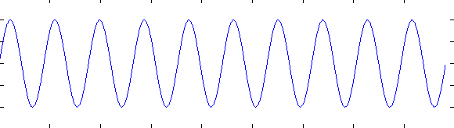

Resulting audio:

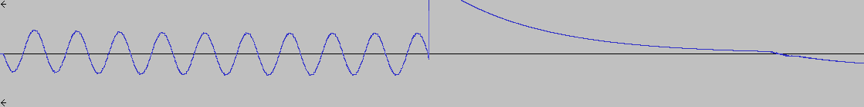

**100Hz 0.1Amp Sine for 0.1s, 16-bit data/audio, sample=(int)(127*(data+1.0))**

Data sent to OpenAL functions: Same but offset by 1.0

Resulting audio: All messed up.

**100Hz 0.1Amp Sine for 0.1s, 32-bit data/audio, sample=data (or sample=pow(2,31)*data, or sample=pow(2,31)*(data+1))**

Resulting audio: No output (~0 speaker displacement)